Game design document

1, Background

* 1. Currently, the popular game gradually divided into the two extremes:
  2. large game：Like 2ksports, Battlefield, Crysis
  3. Mini game：Flappy Bird，Hit the plan on Wechat
  4. Our game will focus on the mini game.

2, Design concept

* 1. light fun and no pressure
  2. For the big games, it often can bring strong sensory stimulation, to players and produce intense pleasure. The requirement for players followed also improved accordingly. The requirements include: attention, observation ability, anticipation ability, etc.
  3. The difference from the large games, the mini game has the low cost of study, no pressure, and can help players to enjoy the entertainment in spare time.
  4. low cost
  5. Mini game the player has natural advantages in development, download and install, learning cost, etc. This is our design concept.

3, Selling Point

* 1. Easy： Make people use it for fun easily. The cost of studying is zero.
  2. Atmosphere relaxed： The goal of all games is interesting. So, our game should make sure that the player will love it.
  3. There is a certain playability)： We should not only guarantee the atmosphere of the game, but also ensure the playability of the game, try to be a certain playability, and even make sure the players do not want to stop!)

4, The demo

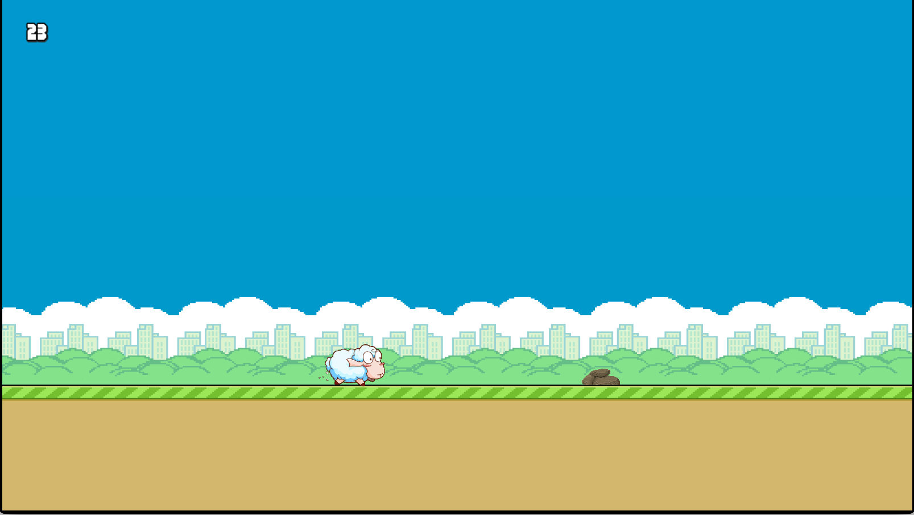

b)

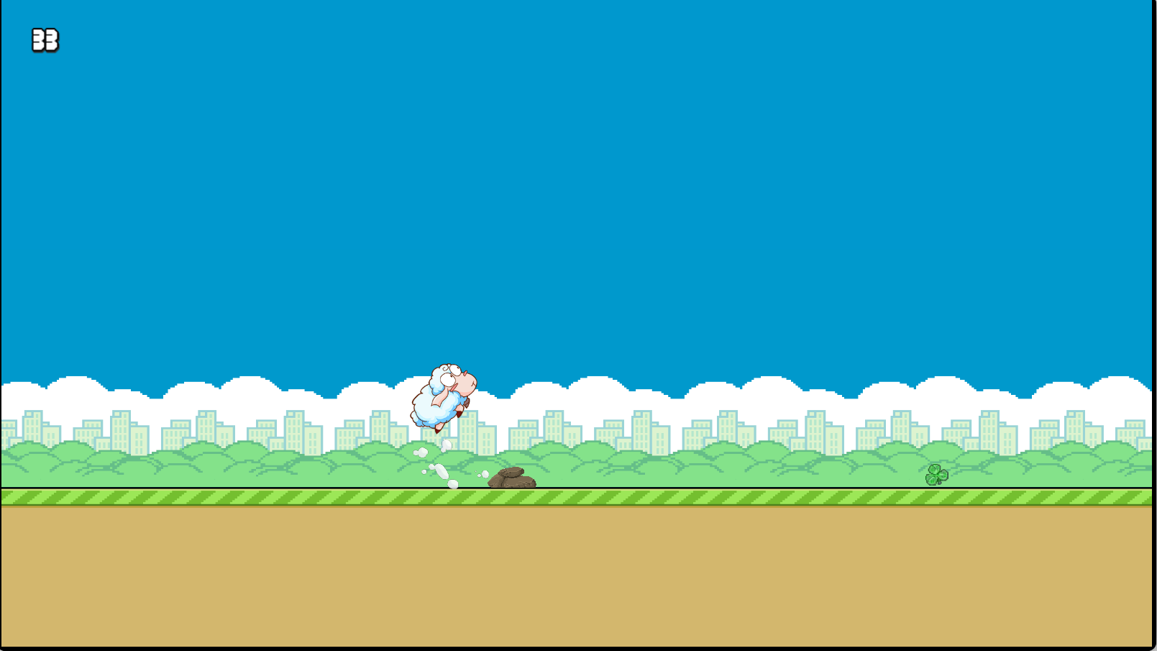

c)

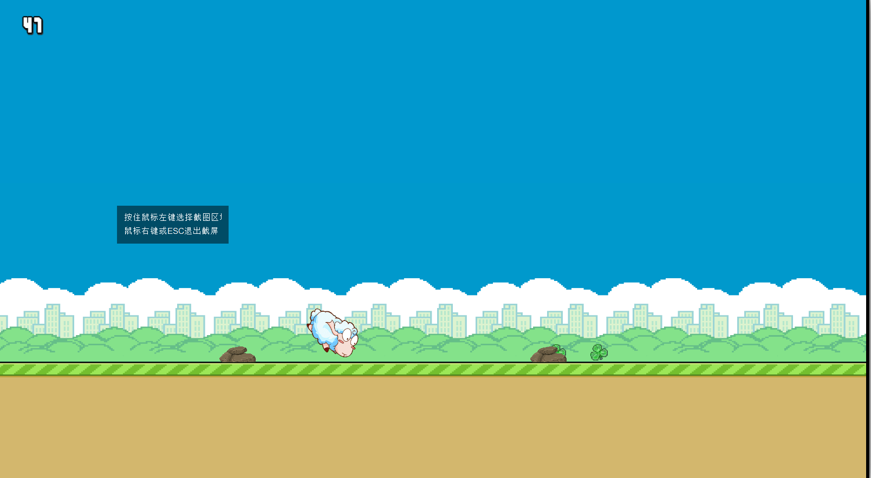

d)

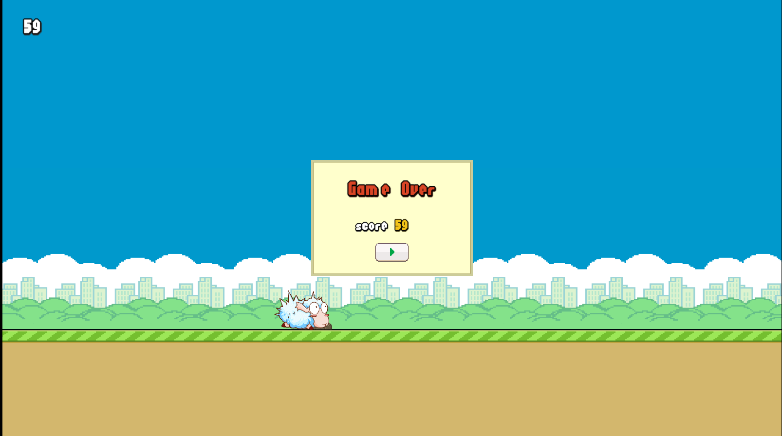

5, The future and the commerce plan

* 1. We will make it into a mobile application, add embedded advertisements
  2. The game can run in the browser through computers and mobile phones